Home analysis – 3
D8 opening

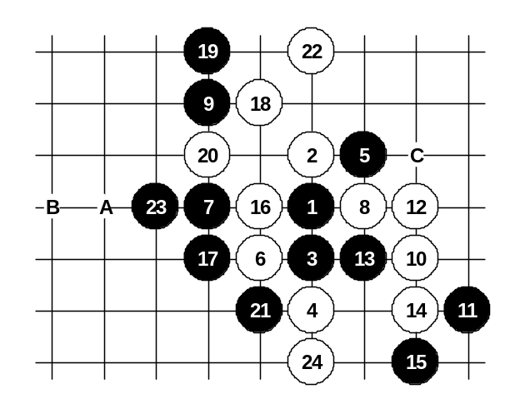
For the advanced class.
Recently, this variant has been one of my favorite home analyses. Actually this is very old variant, people used to play this about 15-20 years ago. I know that Japanese are usually very good at knowing old theories, but surprisingly I have noticed, that Japanese are not sure how to play here as white. Therefore they often play 22-24. Even when they play 24-24, they mix up the moves somewhere later and fail the white attack. For example, in the World Championship in 1997, Nara (8 dan) played this 21st move against Kawamura (9 dan) and Kawamura did not know how white should play and finally he lost that game. The white attack here is very long and hard. Even one small mistake in attack will cause the failure of the attack. The right sequence of moves is very important. I can suggest this analysis only for advanced players because of its difficulty level. Besides, white does not have sure win everywhere, in some cases white will achieve a big positional advantage below instead of sure win, these moves I will not discuss here.
The moves 22, 23 and 24 are the beginning steps for the long winning attack. In move 25 black has several choices. I will only show the most fighting black moves A, B and C here.
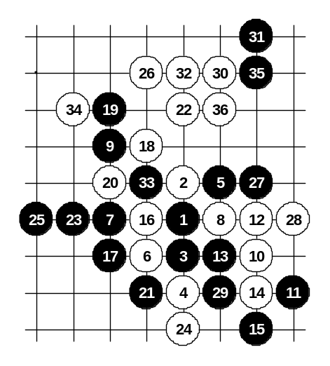
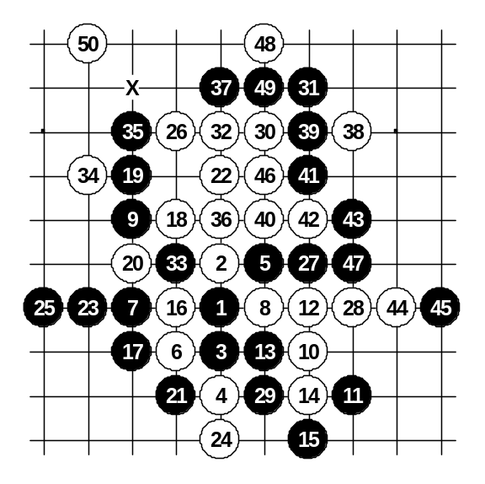

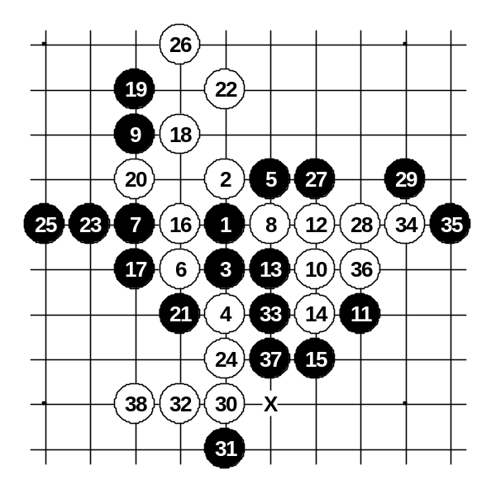
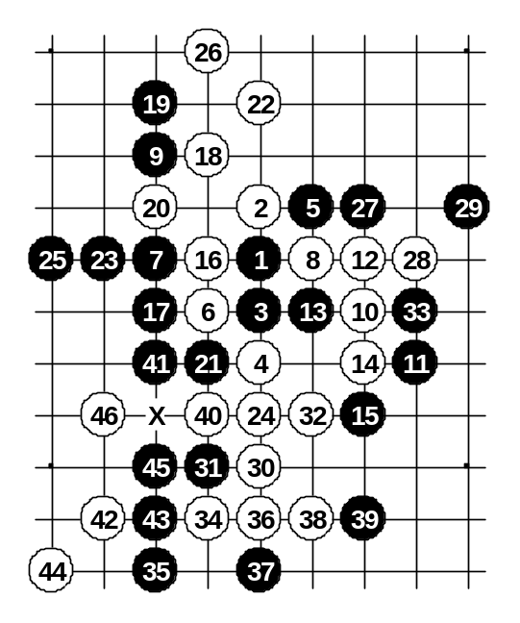

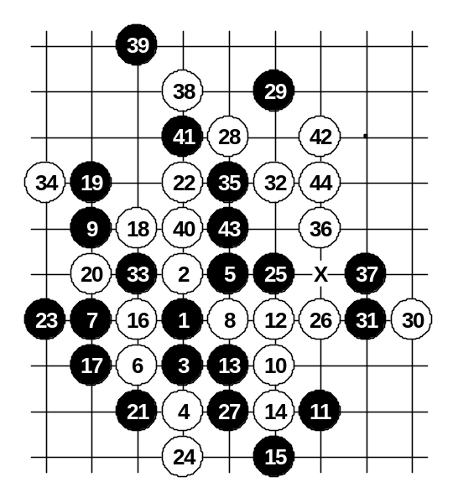
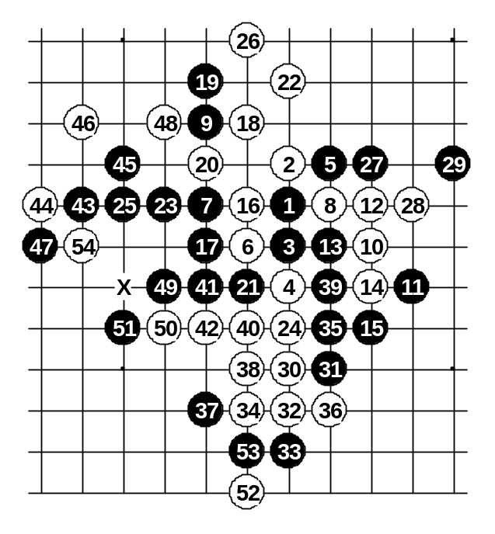
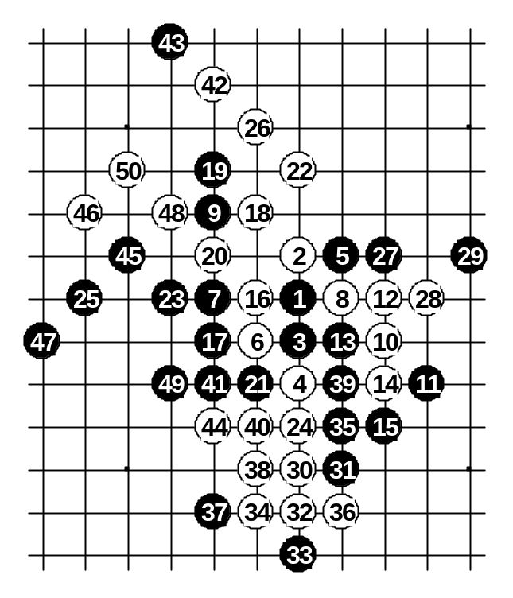
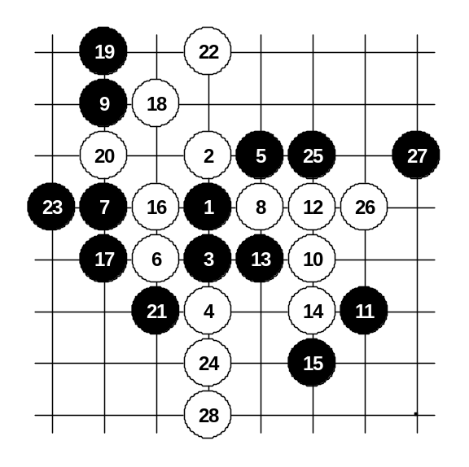

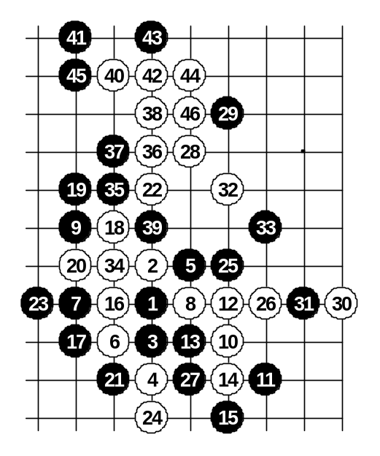
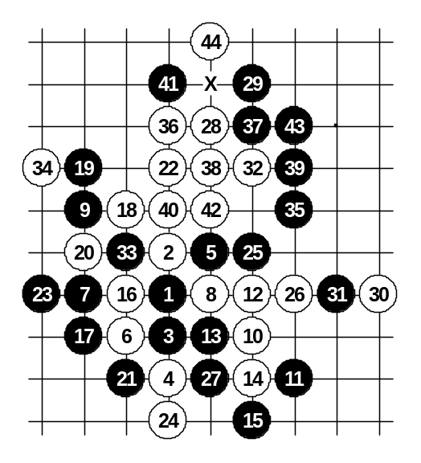

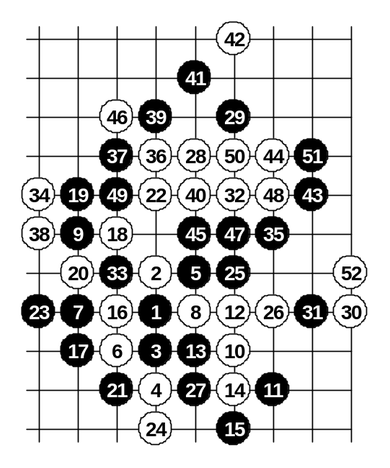
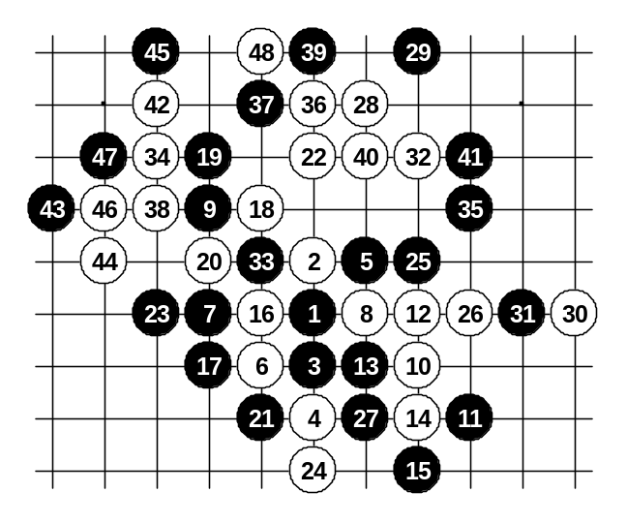
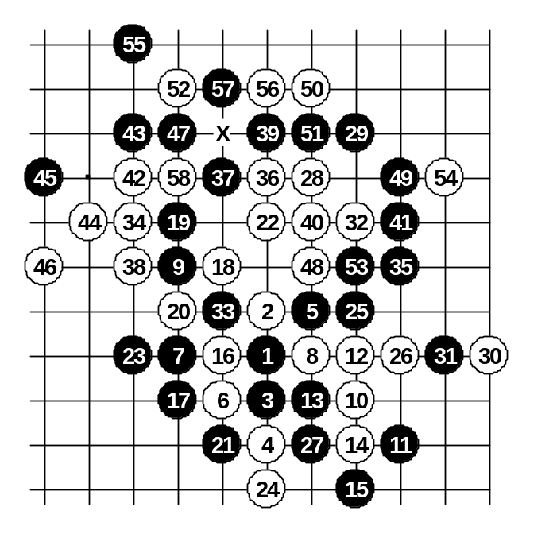
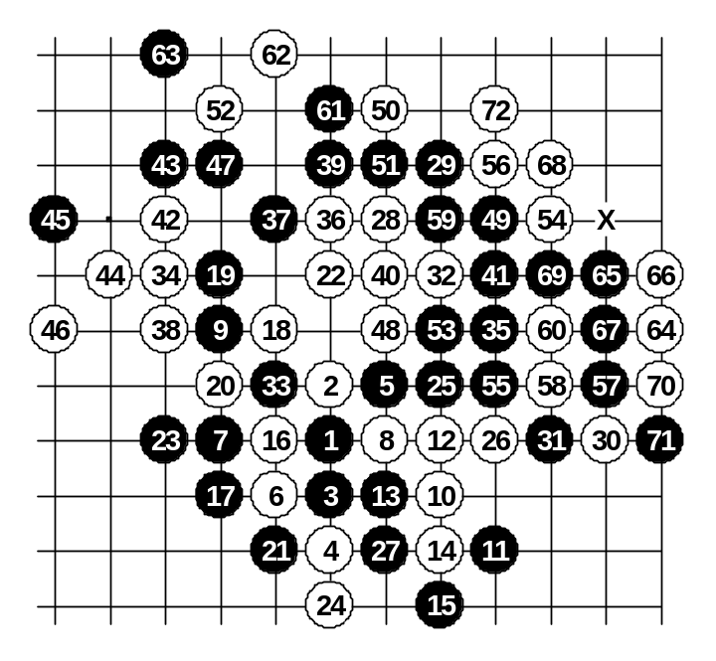
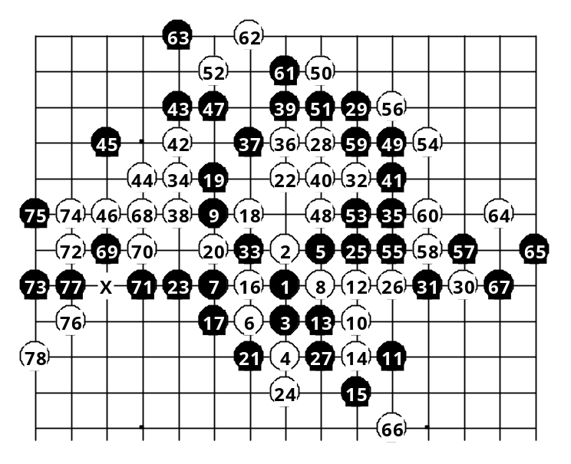
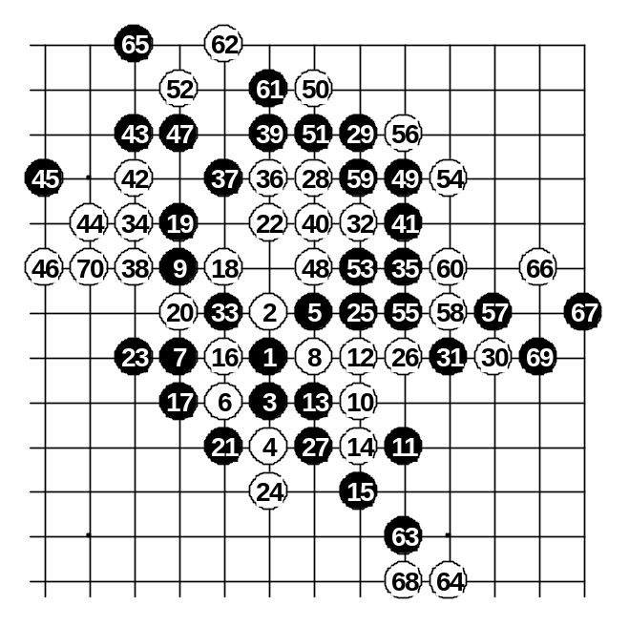

As an explanation to the last two diagrams above, after 64th move white has winning power in both left and right side. However, the black construction in the lower side was an obstacle – it was controlling the white’s right side attack directly with counter-force and white’s left side attack remotely because of tempo. But as soon as white simply played a stone in lower side and stopped black force then black became unable to defend both white dangers.

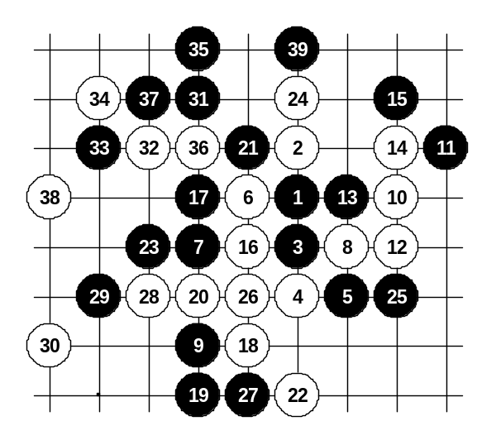
When you looked the last World Championship games and wondered why I played such 21st move against Ants Soosyrv (look at the diagram below) then you should look carefully and notice the difference – I played the 5th move closer to the board edge. As a result, white does not have enough space for attack because the board edge is too near. After playing his 22nd move Ants understood that white would have no good continuation in the attack, so he was forced to switch over to defense.
If the 5th move is played like I did against Ants then I think white should choose 22-24.

